NỀN TẢNG HỌC TẬP THÍCH ỨNG CHO CÁC MÔN LẬP TRÌNH BẬC ĐẠI HỌC: TÍCH HỢP TRUY VẾT TRI THỨC BAYES, XẾP HẠNG ELO, BANDIT ĐA CÁNH TAY VÀ LỊCH LẶP LẠI CÁCH QUÃNG FSRS
Tác giả: Nguyễn Tuấn Dương, Lớp 1C22, Khoa Công Nghệ Thông Tin
Giáo viên hướng dẫn: ThS. Bùi Quốc Khánh
Tóm tắt: Các môn lập trình cơ bản ở bậc đại học có tỷ lệ không đạt khoảng 30–40%, chủ yếu do sự không tương thích giữa tính cá nhân hóa, dựa trên thực hành của việc học lập trình và mô hình giảng dạy đại trà trong lớp học. Nhiều nền tảng học lập trình trực tuyến hiện nay cung cấp kho bài tập phong phú, nhưng chủ yếu dựa trên phân loại độ khó tĩnh và chưa có cơ chế thích ứng theo đặc điểm của từng người học. Bốn kỹ thuật truy vết tri thức Bayes (BKT), xếp hạng Elo, bandit đa cánh tay (MAB) và lặp lại cách quãng FSRS chủ yếu được nghiên cứu riêng lẻ, và các công trình tích hợp đồng thời trong giáo dục lập trình còn rất hạn chế. Do đó, bài báo đề xuất một nền tảng học tập thích ứng với cơ chế cập nhật bất đồng bộ bốn lớp trên đồ thị tri thức 28 khái niệm cho mỗi lần nộp mã nguồn, kèm lớp phản hồi Socratic tùy chọn. Từ đó, nghiên cứu này đưa ra hai đóng góp chính: (1) thiết kế và triển khai một nền tảng học tập thích ứng năm lớp, tích hợp BKT, Elo, bandit phân cấp và FSRS dưới một đồ thị tri thức chung; trong đó, hệ bandit được ràng buộc bởi điều kiện tiên quyết dựa trên ước lượng mức thông thạo từ BKT, và hệ thống xây dựng một ánh xạ từ các lần nộp bài sang cơ chế lập lịch ôn tập của FSRS; (2) một giao thức đánh giá thí điểm được đăng ký trước, trong đó thiết kế nghiên cứu lớp học nhằm đo lường tác động của nền tảng đối với kết quả học tập. Bài báo này nên được hiểu là một công trình triển khai kèm theo giao thức đánh giá; nghiên cứu thực nghiệm chưa được thực hiện.
Từ khoá: Bandit đa cánh tay; Giáo dục lập trình; Học tập thích ứng; Lặp lại cách quãng; Truy vết tri thức Bayes.
AN ADAPTIVE LEARNING PLATFORM FOR UNIVERSITY PROGRAMMING COURSES: INTEGRATING BAYESIAN KNOWLEDGE TRACING, ELO RATING, MULTI-ARMED BANDITS, AND FSRS
Abstract: Introductory programming courses report failure rates of 30–40%, driven by a persistent mismatch between the individualized, practice-intensive nature of programming skill acquisition and the uniform delivery model of large-class instruction. Existing online coding platforms provide extensive problem libraries but rely on static difficulty classifications and lack closed-loop mechanisms for learner adaptation. Individual adaptive techniques such as Bayesian Knowledge Tracing (BKT), Elo rating, Multi-Armed Bandits (MAB), and the Free Spaced Repetition Scheduler (FSRS) have been studied in isolation, but have not been systematically integrated into a unified system for programming education. Therefore, this paper proposes an adaptive learning platform in which each code submission triggers asynchronous updates across four adaptive layers built on a knowledge graph of 28 programming concepts, complemented by an optional Socratic feedback layer. Based on this system, this study makes two main contributions: (1) the design and implementation of an integrated five-layer adaptive platform that unifies BKT, Elo, hierarchical MAB, and FSRS under a shared knowledge graph. It introduces a prerequisite-constrained hierarchical bandit with BKT-based mastery gating and a mapping from code submissions to FSRS ratings.(2) a pre-registered pilot evaluation protocol specifying a planned classroom study to measure the learning effects of the platform. The work is an implementation study accompanied by this protocol rather than a completed classroom evaluation.
Keywords: Adaptive learning; Bayesian knowledge tracing; Multi-armed bandit; Programming education; Spaced repetition.

1. Introduction
Introductory programming courses at universities remain one of the most persistent pain points in undergraduate computing education. A systematic literature review by Luxton-Reilly et al. (2018) reported global failure rates of 30–40% in CS1 courses, a figure that has remained remarkably stable across several decades of pedagogical experimentation. The root cause is not a shortage of practice material but a structural mismatch between how programming skill is acquired and how it is taught: acquisition is individualized and practice-intensive, while delivery is uniform and resource-constrained.
The adaptive learning literature has developed several well-established approaches that address this mismatch at the individual level: Bayesian Knowledge Tracing (BKT) estimates per-concept mastery from interaction traces (Corbett & Anderson, 1995), Elo-style rating dynamically calibrates problem difficulty relative to learner ability (Pelánek, 2016), Multi-Armed Bandit (MAB) formulations with Thompson Sampling balance exploration and exploitation when selecting the next learning activity (Chapelle & Li, 2011; Rollinson & Brunskill, 2015), and the Free Spaced Repetition Scheduler (FSRS) optimizes review intervals to counter skill decay (Ye et al., 2022).
Despite these developments, commercial coding platforms such as LeetCode, HackerRank, and Codeforces provide very large problem libraries but rely on static difficulty tags and offer no closed-loop mechanism for personalization, while large-scale adaptive platforms such as Duolingo demonstrate the scalability of adaptive techniques in language learning and suggest potential transfer to programming education.
However, to the best of our knowledge, no prior work identified in this review integrates all four techniques into a unified, closed-loop system for programming education. Each component has been studied in isolation or in pairs, and claims about individual gains do not automatically compose. The integration itself, including the use of BKT mastery estimates to gate MAB arm availability, the use of Elo to narrow the candidate set to a learner’s zone of proximal development, and the use of FSRS to schedule reviews of previously mastered concepts, requires architectural design that has not yet been systematically explored in this domain.
To address this integration gap, an Adaptive Learning Platform for University Programming Courses is designed and implemented in this work. A knowledge graph comprising 28 programming concepts linked by necessary links unifies the platform, which is structured as a five-layer adaptive engine. With an optional fifth layer that offers LLM-based Socratic hints depending on the current knowledge state, each code submission initiates an asynchronous update across all four adaptive levels.
Building upon this system design, this study presents an integrated multi-layer adaptive architecture that incorporates BKT, Elo, hierarchical MAB, and FSRS specifically for programming education at the platform level. The architecture is implemented through a prerequisite-constrained hierarchical bandit, where the eligibility of an arm is determined by BKT mastery estimates and is further refined by Elo-based ZPD constraints. Additionally, it employs FSRS to enhance programming skill retention through a mapping between code submissions and ratings, which, according to the literature reviewed, is one of the first instances reported in this context. The platform is implemented as a fully functional open-source system with a modular web-based architecture and a sandboxed execution environment.
Given this implementation-focused contribution, this paper should be read as an implementation study accompanied by a pre-registered pilot evaluation protocol. The classroom evaluation is planned but not yet completed, and results will be reported separately.

2. Related Work and Theoretical Background
This section reviews the four adaptive techniques that the proposed platform integrates.

2.1. Knowledge tracing
Bayesian Knowledge Tracing (Corbett & Anderson, 1995) models mastery as a two-state hidden Markov process and remains the reference baseline in modern intelligent tutoring systems (Ma et al., 2014) because it is interpretable and data-efficient. Deep Knowledge Tracing (Piech et al., 2015) and subsequent neural variants trade interpretability for predictive accuracy and require orders of magnitude more interaction data. Relevance to this work: BKT is chosen as Layer 1 because it is data-efficient on cold-start cohorts of a few hundred learners and exposes a calibrated mastery estimate to the bandit downstream.

2.2. Difficulty calibration and the Zone of Proximal Development
Pelánek (2016) formalized Elo-style rating for adaptive educational systems, showing that dual student–item ratings converge within roughly twenty attempts per learner, and operationalizes the Zone of Proximal Development (Vygotsky, 1978) and the desirable-difficulties principle (Bjork & Bjork, 2011). Layer 2 adopts dual Elo ratings on this basis, and the Elo deltas feed directly into the ZPD filter that constrains Layer 3.

2.3. Multi-Armed Bandits in education
Thompson Sampling (Chapelle & Li, 2011) is the de facto choice for exploration–exploitation problems with small effective sample sizes, as is typical in one-semester classroom deployments; Segal et al. (2018) extended bandit policies to structured action spaces using hierarchical bandits. Relevance to this work: Layer 3 adopts a two-level hierarchical Thompson-sampling bandit in which the outer level selects the next concept and the inner level selects a problem within it; Section 3.5 describes the prerequisite and ZPD constraints that shape this choice.

2.4. Spaced repetition and FSRS
The spacing effect — that distributed practice produces better long-term retention than massed practice — is among the most robust findings in cognitive psychology (Cepeda et al., 2006). Algorithmic schedulers have evolved from heuristic SM-2 to the Free Spaced Repetition Scheduler (Ye et al., 2022), which formulates the scheduling problem as a stochastic shortest path and reports 20–30% fewer reviews than SM-2 for the same retention target. FSRS has been evaluated mainly on vocabulary and factual-recall tasks, whereas programming is a procedural skill whose decay dynamics are less well understood. Layer 4 applies FSRS to programming skill retention, and Section 3.6 describes the submission-to-rating mapping this application requires.

2.5. Programming platforms and the integration gap
Commercial platforms such as LeetCode, HackerRank, and Codeforces provide large problem libraries but rely on static difficulty tags and static taxonomies; none of them closes the loop from learner outcome back to problem selection. The literature surveyed in this paper does not report a system that simultaneously integrates knowledge tracing, dynamic difficulty calibration, bandit-based selection, and spaced repetition under a shared knowledge graph for programming education. Relevance to this work: this gap is the paper's core motivation, and Table 1 summarizes the four techniques' complementary roles.
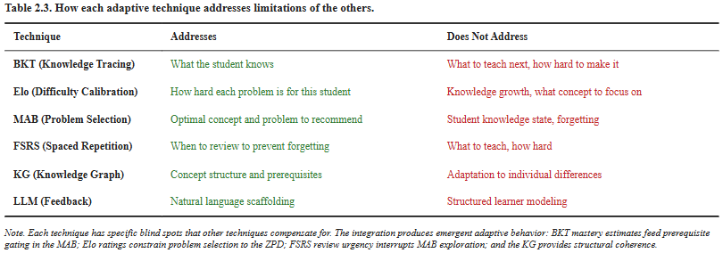
Table 1. Complementary roles of the four integrated adaptive techniques. Source: authors' own work.

3. Methodology

3.1. System overview and closed-loop architecture
The platform is organized as a four-component full-stack web application: a React 18 frontend, a NestJS 10 API gateway, a FastAPI adaptive engine written in Python 3.11, and a PostgreSQL 16 database with a Redis 7 cache. A Docker-based sandbox executes submitted code under strict resource limits (256 MB memory, five-second CPU timeout, unprivileged user, no network). Inside the adaptive engine sits a five-layer adaptive stack, shown in Figure 1. Each code submission triggers an asynchronous event that updates Layers 1–4 in parallel, after which the bandit re-ranks the candidate pool for the next recommendation. This closed-loop behaviour is the central architectural property of the platform: the learner model is never stale.
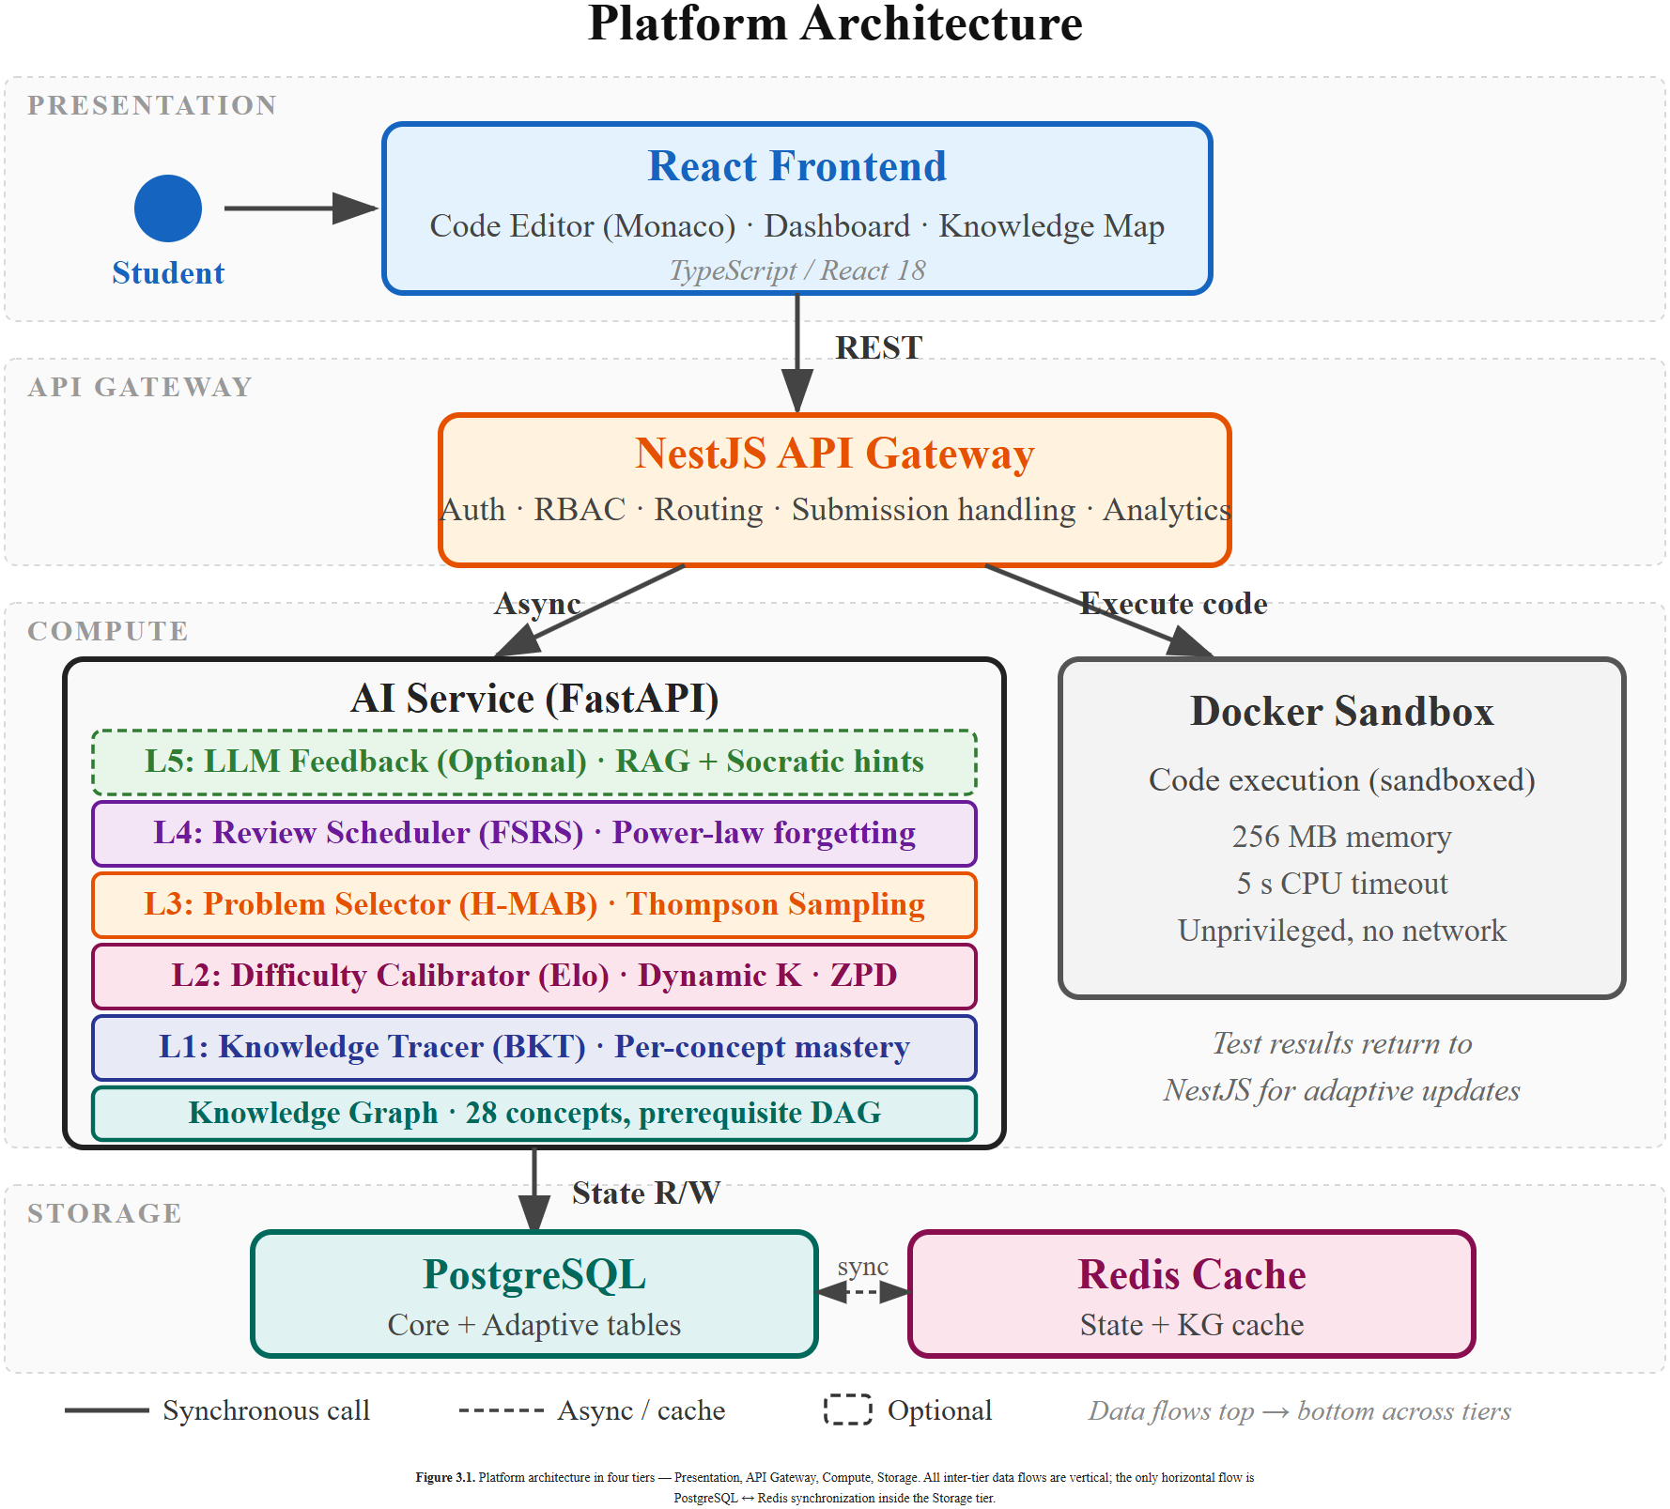
Figure 1. Five-layer adaptive architecture. Source: authors' own work.

3.2. Knowledge graph foundation
All five layers share a single learning artefact: a knowledge graph of 28 programming concepts connected by approximately 45 prerequisite edges, grouped into five difficulty tiers and seven topic clusters (control flow, functions, data structures, recursion, and so on). Every problem in the bank is tagged with one primary concept and zero or more secondary concepts. The graph is authored manually; automated construction from curriculum documents is left as future work. The graph provides the substrate on which BKT estimates are maintained, prerequisite gating is enforced, and FSRS review schedules are aligned.

3.3. Layer 1 — Bayesian Knowledge Tracing
Layer 1 maintains a per-learner, per-concept mastery posterior using the four-parameter BKT formulation of Corbett and Anderson (1995). Prior mastery P(L₀) is initialized per difficulty tier from 0.20 at the Foundations tier down to 0.05 at the Expert tier, with transition probability P(T) scaled similarly (0.30 to 0.10); this tier-stratified initialization reduces the BKT posterior's tendency toward premature confidence on harder concepts before the first few observations arrive. For problems that tag secondary concepts in addition to the primary concept, the BKT posterior for secondary concepts is updated asymmetrically rewarded on success but not penalized on failure to avoid false negatives when a failure on a multi-concept problem cannot be attributed to a specific concept. A concept is considered mastered when its posterior mastery exceeds the mastery threshold θₘ = 0.85, while a separate, lower prerequisite-competence threshold θₚ = 0.60 governs Layer 3 eligibility (see Section 3.5). Both thresholds are design choices informed by the intelligent-tutoring-systems literature rather than values tuned on this dataset; the follow-up pilot will treat them as calibration targets.

3.4. Layer 2 — Dynamic Elo rating
Layer 2 maintains dual Elo ratings: every learner has a rating initialized at 1200, and every problem has a rating initialized at 1000, 1200, or 1400 for Easy, Medium, and Hard tiers respectively, with values clamped to [400, 2800]. The learner-side K is adjusted using an exponential trend weighting computed over a rolling window of the learner's last 10 submissions: rapidly improving or declining trajectories receive larger K values (up to $K_{max}$= 40), while stable trajectories settle toward $K_{min}$ = 10. The problem-side K decays with attempt count as $\frac{K_{max}}{\sqrt{n}}$ to prevent long-established problems from swinging on late outliers. Both formulas are design choices for pre-pilot operation; the pilot will treat them as calibration targets. A ZPD filter then restricts the candidate pool to problems whose rating differs from the learner's current rating by δ ∈ [50, 250] rating points; this operationalizes the desirable-difficulties principle in a form directly usable by Layer 3.

3.5. Layer 3 — Hierarchical MAB with Thompson Sampling
Layer 3 uses a two-level Thompson-sampling bandit. The outer arm selects the next concept to practise; the inner arm selects a specific problem within that concept. Arm eligibility at the outer level is gated by a prerequisite constraint derived from the knowledge graph: a concept becomes eligible only when every one of its prerequisite concepts has reached the prerequisite-competence threshold θₚ = 0.60, which is deliberately set below the mastery threshold θₘ = 0.85 used for completion status; this separation allows the bandit to introduce a new concept as soon as its prerequisites are workably solid, without requiring full mastery first. At the inner level, the ZPD filter from Section 3.4 removes out-of-range problems. The reward function combines three components into a scalar in [0, 1]: expected BKT learning gain with weight w₁ = 0.5, correctness signal w₂ = 0.3, and solve-time efficiency w₃ = 0.2. These weights are a heuristic combining learning gain, difficulty match, and efficiency; they are not learned from empirical data, and re-estimating them from the pilot traces is explicitly listed as future work.

3.6. Layer 4 — FSRS and the submission-to-rating mapping
Layer 4 maintains an FSRS-5 state (19 parameters, defaults from Ye et al., 2022) per learner–concept pair, scheduling reviews when retrievability drops below 0.9. The technical novelty at this layer is the mapping from a code submission outcome to an FSRS rating. FSRS was designed for flashcard recall and expects one of four discrete ratings: Again, Hard, Good, Easy. Programming submissions offer a richer signal space: correctness on hidden tests, number of attempts, and time spent. The signal space is mapped to FSRS ratings through a decision rule that combines correctness (all tests passed vs partial vs failed), attempt count (first-try vs retries), and time relative to the learner's median on problems of the same difficulty tier. Concretely, the mapping assigns a first-attempt correct submission under 120 seconds to Easy (FSRS rating 4), under 300 seconds to Good (rating 3), and at or above 300 seconds to Hard (rating 2); any submission requiring multiple attempts is capped at Hard, and any incorrect final submission is mapped to Again (rating 1). The two time boundaries were chosen so that an average Medium-tier problem solved on the first attempt would typically land on Good. Based on the literature surveyed, this appears to be among the first reported applications of FSRS to programming skill retention.

3.7. Layer 5 — Optional LLM feedback
Layer 5 provides Socratic-style hints via a retrieval-augmented generation pipeline grounded in the learner's current BKT state (Wang et al., 2023). The layer is designed as a feature-flagged capability that is disabled in both the experimental and control arms of the pilot, so that the measurement of the adaptive recommendation logic in Layers 1–4 is not confounded by the hint channel.

3.8. Pre-registered pilot evaluation protocol
A between-subjects, pre-test/post-test design with a control group is pre-registered. The experimental group uses Layers 1–4 of the adaptive engine (Layer 5 LLM hints are disabled in both arms to prevent the hint channel from confounding the measurement of the adaptive recommendation logic itself); the control group uses the identical platform with the adaptive layers replaced by legacy content-based filtering. The control group is constructed to hold constant the platform interface and problem environment while varying only the recommendation logic. The protocol targets n = 40–60 Hanoi University undergraduates across four weeks of intervention with a Week 8 retention follow-up, and IRB review has been completed. Figure 2 summarizes the eight-week timeline. The primary research question (RQ1) concerns predictive validity: whether BKT and Elo mastery estimates predict post-intervention item correctness with AUC ≥ 0.70. Acceptance rate and convergence speed are treated as supporting indicators for RQ1 rather than primary outcomes.
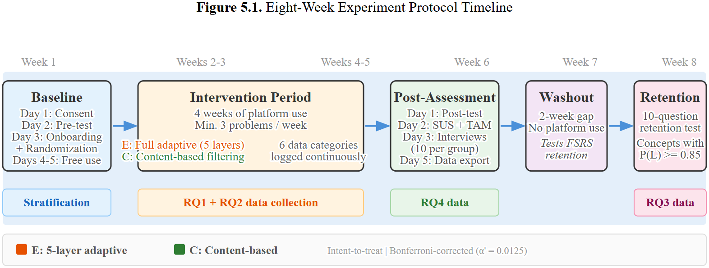
Figure 2. Eight-week pilot evaluation timeline. Source: authors' own work.

4. Implemented Artifact and Design Discussion
This paper adopts a design-paper framing. Accordingly, Section 4.1 reports the implemented artefact and its operational characteristics as the primary results, and Section 4.2 discusses the design relative to literature benchmarks. Empirical learning-outcome results will be reported separately after the pre-registered pilot (Section 3.8) is executed.

4.1. Implemented Artifact
Deployment and code metrics. The platform is deployed and operational. The adaptive engine comprises approximately 3,900 lines of Python; the NestJS backend extensions add approximately 6,400 lines of TypeScript; and the React frontend contributes approximately 8,400 lines of TypeScript and TSX. The knowledge graph encodes 28 programming concepts with 45 prerequisite edges across five difficulty tiers and seven topic clusters. The code execution sandbox runs each submission under a 256 MB memory limit, a five-second CPU timeout, an unprivileged user, and a disabled network. Under load testing, the recommendation endpoint produces a new Thompson-sampled choice in under 500 ms at a target of 100 concurrent users, satisfying the non-functional requirement established at design time. The source repository, Docker Compose deployment, and configuration templates are packaged as a single open-source release. The learner-facing frontend surfaces the adaptive engine's internal state through three purpose-built views: (i) an interactive prerequisite-graph visualization of the 28-concept knowledge graph in which node opacity encodes current BKT mastery and edge visibility encodes prerequisite satisfaction; (ii) a review queue that renders each due item's FSRS retrievability as a circular indicator and splits the queue into due-now and upcoming segments; and (iii) a progressive three-level Socratic hint panel whose prompts are grounded in the learner's current code, error output, and Layer 1 mastery state. These views are deliberate: the closed-loop pipeline of Figure 3 is a backend property, but it becomes actionable only if the learner can inspect and respond to the state it produces. Taken together, the deployed system, the packaged source repository, and the reproducible Docker-based configuration constitute concrete evidence that the platform has been implemented rather than merely specified.
Closed-loop walk-through. Figure 3 illustrates the submission pipeline for one concrete scenario. A learner submits a solution to a problem tagged with the primary concept recursion. The sandbox runs the submission against hidden test cases, produces a correctness signal, an attempt count, and a wall-clock solve time. An asynchronous event then triggers four updates in parallel. Layer 1 updates the learner's BKT posterior for recursion; Layer 2 updates both the learner's Elo rating and the problem's Elo rating; Layer 4 computes an FSRS rating from the correctness–attempts–time triple and rewrites the next review date; and Layer 3 receives the updated learner state and re-ranks the candidate pool for the next recommendation. Every subsequent recommendation issued to this learner reflects the full updated state. No layer operates on stale information.
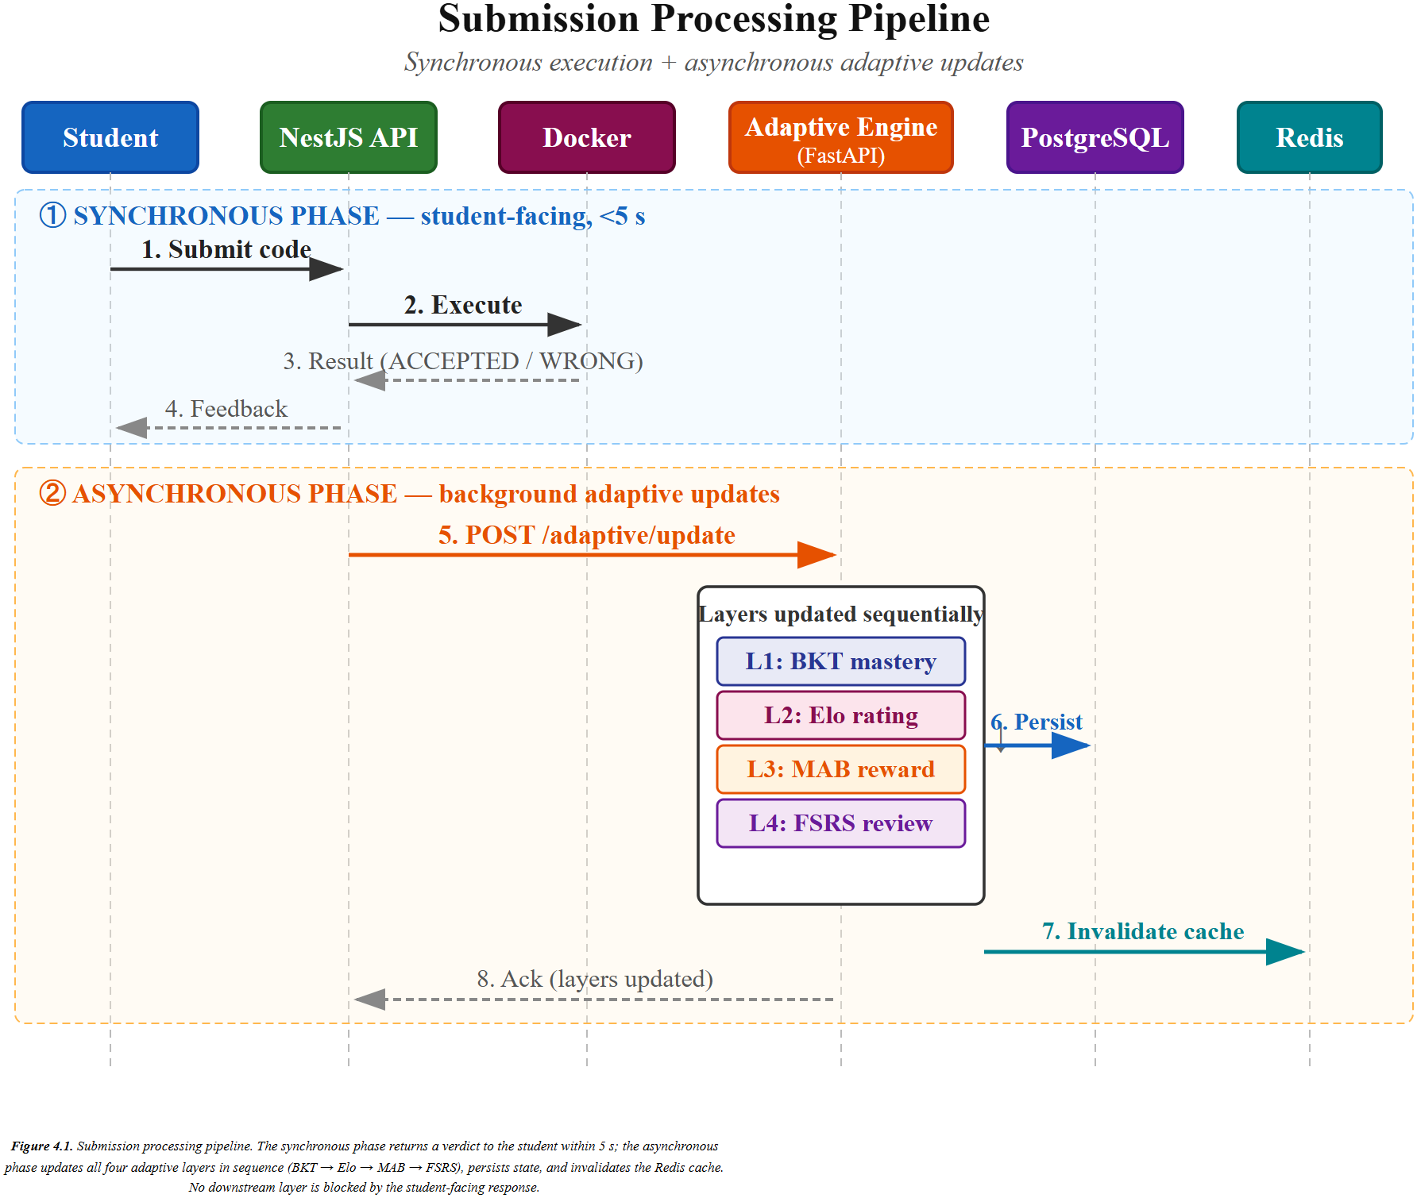
Figure 3. Closed-loop submission pipeline executed after every code submission. Source: authors' own work.
Evaluation protocol status. The evaluation described in Section 3.8 is a pre-registered pilot, not a completed study. The study design is fully specified, the instruments and timeline are in place (Figure 2), and IRB review has been completed. Enrolment and intervention have not yet commenced; results will be reported in a follow-up publication.

4.2. Discussion
Layer-by-layer comparison against literature benchmarks. The design targets for each adaptive layer are drawn from prior empirical work rather than from this platform's own data. For Layer 1, BKT is expected to exceed AUC-ROC 0.70 on post-intervention item correctness, the threshold reported as acceptable across the ITS meta-analysis of Ma et al. (2014). For Layer 2, dual Elo is expected to converge to within one rating tier of ground truth within approximately twenty attempts per learner, matching the convergence behaviour observed by Pelánek (2016). For Layer 4, FSRS is expected to deliver retention comparable to SM-2 with roughly twenty to thirty percent fewer reviews, replicating the scheduling gain reported by Ye et al. (2022) on flashcard corpora. These are design targets: they anchor the pilot's analysis plan but they are not claims about system performance.
Why the integration is more than the sum of its parts. The override channel between Layer 4 and Layer 3 is the clearest operational evidence for this claim. When the FSRS retrievability estimate for a previously mastered concept falls below 0.9, Layer 3's outer-arm sampling is overridden and the concept is surfaced as a review recommendation regardless of its current Thompson posterior. This override is the mechanical realization of the composition described in Table 1: Layer 4 issues urgency, Layer 1 supplies eligibility, Layer 2 narrows the candidate pool, and Layer 3 arbitrates exploration versus exploitation within the surviving set. Each handoff is simple, but their composition yields an emergent recommendation policy that no single technique achieves alone. This is the structural claim the paper makes: integration, not any individual layer, is the contribution.
However, no empirical learning-gain data is reported in this paper. The planned evaluation is single-site, which limits external validity, and the between-subjects comparison will measure the effect of the bundled four-layer treatment against a non-adaptive baseline rather than isolating individual layer contributions. Contribution 1, the integrated platform, is implemented and demonstrated technically. Contribution 2, the evaluation, is specified but not yet empirically executed. The thesis from which this paper is drawn will report the pilot in full; this conference paper records the design and the deployable artefact.

5. Conclusion
This paper has presented the design and implementation of a five-layer adaptive learning platform for university programming courses. The platform integrates Bayesian Knowledge Tracing, dynamic Elo rating, hierarchical Multi-Armed Bandits with Thompson Sampling, and the Free Spaced Repetition Scheduler into a single closed-loop system unified by a knowledge graph of 28 programming concepts. The first contribution is the integrated platform itself, whose design embeds a prerequisite-constrained hierarchical bandit with BKT-mastery gating and a code-submission-to-FSRS-rating mapping as internal technical details rather than as separate claims. The second contribution is a pre-registered pilot evaluation protocol that specifies the classroom study in which the platform's learning effect will be measured. An open-source implementation accompanies the design.
The artefact-versus-plan distinction deserves explicit restatement. Contribution 1 — the integrated platform — is implemented and demonstrated technically: the system is deployed, meets its latency and sandboxing non-functional requirements, and is released as open-source software. Contribution 2 — the empirical evaluation — is specified in Section 3.8, IRB-reviewed, and pre-registered, but the classroom pilot has not yet been conducted. The follow-up thesis and subsequent publications will report the pilot results.
Future work follows directly. The immediate priority is executing the pre-registered pilot (n = 40–60 Hanoi University undergraduates across four weeks of intervention with a Week 8 retention follow-up) and reporting BKT and Elo predictive-validity AUC, FSRS review efficiency, and normalized learning gain. Medium-term work includes a multi-site replication to address the single-site limitation, a within-system ablation that quantifies each adaptive layer's marginal contribution, and a full evaluation of the optional LLM Layer 5, which was excluded from the pilot. By integrating four adaptive techniques that have, until now, been studied in isolation, this paper offers a concrete architectural step toward the long-standing ambition of individualized programming education at scale.

References
1. Bjork, R. A., & Bjork, E. L. (2011). Making things hard on yourself, but in a good way: Creating desirable difficulties to enhance learning. In M. A. Gernsbacher, R. W. Pew, L. M. Hough, & J. R. Pomerantz (Eds.), Psychology and the real world: Essays illustrating fundamental contributions to society (pp. 56–64). Worth Publishers.
2. Cepeda, N. J., Pashler, H., Vul, E., Wixted, J. T., & Rohrer, D. (2006). Distributed practice in verbal recall tasks: A review and quantitative synthesis. Psychological Bulletin, 132(3), 354–380. https://doi.org/10.1037/0033-2909.132.3.354
3. Chapelle, O., & Li, L. (2011). An empirical evaluation of Thompson sampling. In Advances in Neural Information Processing Systems (Vol. 24, pp. 2249–2257). Curran Associates.
4. Corbett, A. T., & Anderson, J. R. (1995). Knowledge tracing: Modeling the acquisition of procedural knowledge. User Modeling and User-Adapted Interaction, 4(4), 253–278. https://doi.org/10.1007/BF01099821
5. Luxton-Reilly, A., Simon, Albluwi, I., Becker, B. A., Giannakos, M., Kumar, A. N., Ott, L., Paterson, J., Scott, M. J., Sheard, J., & Szabo, C. (2018). Introductory programming: A systematic literature review. In Proceedings of the 2018 ITiCSE Conference on Working Group Reports (pp. 55–106). ACM. https://doi.org/10.1145/3293881.3295779
6. Ma, W., Adesope, O. O., Nesbit, J. C., & Liu, Q. (2014). Intelligent tutoring systems and learning outcomes: A meta-analysis. Journal of Educational Psychology, 106(4), 901–918. https://doi.org/10.1037/a0037123
7. Pelánek, R. (2016). Applications of the Elo rating system in adaptive educational systems. Computers & Education, 98, 169–179. https://doi.org/10.1016/j.compedu.2016.03.017
8. Piech, C., Bassen, J., Huang, J., Ganguli, S., Sahami, M., Guibas, L., & Sohl-Dickstein, J. (2015). Deep knowledge tracing. In Advances in Neural Information Processing Systems (Vol. 28, pp. 505–513). Curran Associates.
9. Rollinson, J., & Brunskill, E. (2015). From predictive models to instructional policies. In Proceedings of the 8th International Conference on Educational Data Mining (pp. 179–186). International Educational Data Mining Society.
10. Segal, A., Gal, Y., Kamar, E., Horvitz, E., & Miller, G. (2018). Optimizing interventions via offline policy evaluation: Studies in citizen science. In Proceedings of the AAAI Conference on Artificial Intelligence (Vol. 32, pp. 3893–3900). AAAI Press. https://doi.org/10.1609/aaai.v32i1.11852
11. Settles, B., & Meeder, B. (2016). A trainable spaced repetition model for language learning. In Proceedings of the 54th Annual Meeting of the Association for Computational Linguistics (pp. 1848–1858). ACL. https://doi.org/10.18653/v1/P16-1174
12. Vygotsky, L. S. (1978). Mind in society: The development of higher psychological processes. Harvard University Press.
13. Wang, R. E., Wirawarn, Q., Goodman, N., & Demszky, D. (2023). SocraticLM: Exploring Socratic questioning strategies in language models. In Findings of the Association for Computational Linguistics: EMNLP 2023 (pp. 3070–3084). ACL.
14. Ye, J., Su, J., & Cao, Y. (2022). A stochastic shortest path algorithm for optimizing spaced repetition scheduling. In Proceedings of the 28th ACM SIGKDD Conference on Knowledge Discovery and Data Mining (pp. 4381–4390). ACM. https://doi.org/10.1145/3534678.3539081

